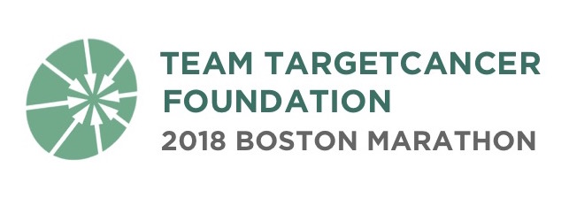
TargetCancer Foundation 2018 Boston Marathon Team Application

Thank you very much for your interest in running the 2018 BAA Boston Marathon as a member of Team TargetCancer Foundation (TCF)! Through its participation in the John Hancock Non-Profit Program, TCF has a limited number of bibs available for charity runners. We are seeking runners who have previous race experience, have raised funds for charitable organizations or causes, and are committed to the mission of raising money to support rare cancer research.

Please note that if selected, you will be required to commit to raising a minimum of $7,500. However, in order to return to this program year after year, TCF is expected to keep up with the average fundraising of other teams in the program, which last year was $11,600. As a result, our expectation is that each Team TCF runner will raise $11,000 or more.

Please read all of the requirements on page 4 of this application before completing and submitting your application. All applications must be received by Friday, October 20, 2017. Please return completed applications to Samantha Sullivan: samantha@targetcancerfoundation.org.

Contact Information:

Name: ___________________________________________________________________

Home Address: ___________________________________________________________________
City, State, Zip: ___________________________________________________________________

Phone: _____________________________ Email: _______________________________

Employer: ___________________________________________________________________

Does your employer have a gift-matching program? [ ] Yes [ ] No [ ] Unsure

Gender: [ ] Female [ ] Male

Age as of April 16, 2018: ___________________ Date of Birth: _______________________

Your Previous Experience:

Have you completed a half or full marathon? [ ] Yes [ ] No

If yes, which half/marathon(s) have you run? _______________________________________________

What is your goal Marathon finishing time? ________________________________________________

Have you participated in a fundraising charity program before? [ ] Yes [ ] No

If so, for which charity and how much did you raise? _________________________________________

What is your fundraising goal for the 2018 Boston marathon? __________________________________

Reaching such a high fundraising goal requires a comprehensive fundraising plan over a 5-month period. What are your specific plans for how you will achieve your fundraising (minimum $7,500, expected $11,000+) goal?

Are there any specific ways TargetCancer Foundation can support you in helping you achieve your fundraising goal?

Please describe why you would like to run the marathon for Team TargetCancer Foundation and raise funds for rare cancer research.

Please attach additional sheets for longer answers.

PLEASE READ CAREFULLY BEFORE SUBMITTING:

Because of the limited number of participants allowed into this program, it is important that the applicant clearly understand the below guidelines and requirements of this philanthropic agreement.

If accepted as a member of Team TargetCancer Foundation, you would be committing to the following:

- You will raise a minimum of $7,500, with a goal of $11,000 or more, to support TargetCancer Foundation by May 31, 2018. All funds must be raised, collected by participants, and postmarked prior to this deadline.

- You will agree to allow a $7,500 authorization to your credit card, and understand that you will be charged for any difference between the amount you raise and the $7,500 minimum.

- You will provide regular training and fundraising updates to be posted on your individual Crowdrise fundraising page, TargetCancer Foundation website, and TargetCancer Foundation social media channels.

- You agree to allow your name and photographs to be posted on your individual Crowdrise fundraising page, TargetCancer Foundation website, and TargetCancer Foundation social media channels.

- You will complete all applicable Boston Marathon registration forms and submit payment for the BAA registration fee of $350 (or higher amount as determined by the BAA).

- You agree to not hold TargetCancer Foundation responsible for any injury or death related to training for, or participation in, the Boston Marathon as part of Team TargetCancer Foundation.

- You understand that you are solely responsible for raising or personally giving the entire fundraising minimum even if for any reason, including injury, you are unable to run the 2018 Boston Marathon.

- You understand that a runner number cannot be transferred to another individual.

- You will submit all completed official registration materials by their respective due dates.

By submitting this application, I verify that I have read and commit to the above guidelines.

Signature of applicant: ______________________________________________________________

Date: ______________________________________________________________

