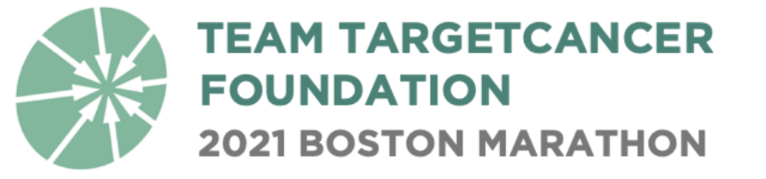

TargetCancer Foundation 2021 Boston Marathon Team Application

Thank you very much for your interest in running the 2021 BAA Boston Marathon as a member of Team TargetCancer Foundation (TCF)! Through its participation in the John Hancock Non-Profit Program, TCF has a limited number of bibs available for charity runners. We are seeking runners who have previous race experience, have raised funds for charitable organizations or causes, and are committed to the mission of raising money to support rare cancer research.

Please note that if selected, you will be required to commit to raising a minimum of $7,500.

Please read all of the requirements on page 4 of this application before completing and submitting your application. All applications must be received by Friday, May 21, 2021. Please return completed applications to Samantha Sullivan: samantha@targetcancerfoundation.org.

Contact Information:

Name: ___________________________________________________________________

Home Address: ___________________________________________________________________
City, State, Zip: ___________________________________________________________________

Phone: _____________________________ Email: _______________________________

Employer: ___________________________________________________________________

Does your employer have a gift-matching program? [ ] Yes [ ] No [ ] Unsure

Gender: [ ] Female [ ] Male

Age as of October 11, 2021: ___________________ Date of Birth: _______________________

Your Previous Experience:

Have you completed a half or full marathon? [ ] Yes [ ] No

If yes, which half/marathon(s) have you run? _______________________________________________

What is your goal Marathon finishing time? ________________________________________________

Have you participated in a fundraising charity program before? [ ] Yes [ ] No

If so, for which charity and how much did you raise? _________________________________________

What is your fundraising goal for the 2021 Boston marathon? __________________________________

Reaching such a high fundraising goal requires a comprehensive fundraising plan over a 5-month period. What are your specific plans for how you will achieve your fundraising (minimum $7,500) goal?

Are there any specific ways TargetCancer Foundation can support you in helping you achieve your fundraising goal?

Please describe why you would like to run the marathon for Team TargetCancer Foundation and raise funds for rare cancer research.

Please attach additional sheets for longer answers.

PLEASE READ CAREFULLY BEFORE SUBMITTING:

Because of the limited number of participants allowed into this program, it is important that the applicant clearly understand the below guidelines and requirements of this philanthropic agreement.

If accepted as a member of Team TargetCancer Foundation, you would be committing to the following:

- You will raise a minimum of $7,500 to support TargetCancer Foundation by October 18, 2021. All funds must be raised, collected by participants, and postmarked prior to this deadline.

- You will agree to allow a $7,500 authorization to your credit card, and understand that you will be charged for any difference between the amount you raise and the $7,500 minimum.

- You will provide regular training and fundraising updates to be posted on your individual GivenGain fundraising page, TargetCancer Foundation website, and TargetCancer Foundation social media channels.

- You agree to allow your name and photographs to be posted on your individual GivenGain fundraising page, TargetCancer Foundation website, and TargetCancer Foundation social media channels.

- You will complete all applicable Boston Marathon registration forms and submit payment for the BAA registration fee of $395 ($370 registration fee and a $25 COVID-offset fee, as determined by the BAA).

- You agree to not hold TargetCancer Foundation responsible for any injury or death related to training for, or participation in, the Boston Marathon as part of Team TargetCancer Foundation.

- You understand that you are solely responsible for raising or personally giving the entire fundraising minimum even if for any reason, including injury or circumstances related to COVID-19, you are unable to run the 2021 Boston Marathon.

- You agree to comply with all protocols and procedures related to COVID-19 mitigation and public health for the 2021 Boston Marathon as stipulated by the Boston Athletic Association.

- You understand that participants in the in-person race may be expected to produce up to two negative COVID-19 tests prior to Monday, October 11, regardless of vaccination status.

- You understand that if you choose to purchase registration insurance through RegShield, it must be purchased during the registration process and cannot be purchased at any other time.

- You understand that a runner number cannot be transferred to another individual or deferred to another year.

- You will submit all completed official registration materials by their respective due dates.

